**Employee Management System**

**Project title :** Employee Management System

**Operating System :** Windows

**Database :** MYSQL

**Technical Requirement’s :** Spring tool suit, VS Code

**Run Time Environment :**

**Backend :** SpringBoot , Rest API

**Frontend** : HTML, CSS, Angular, JavaScript, Bootstrap

**Summary:**

An Employee Management System is a full-stack application involving both front-end and back-end development. On the front end, leverage user-friendly frameworks like Angular or React to create an intuitive interface. Implement essential features such as employee dashboards, profile management. Prioritize secure authentication and authorization mechanisms tailored to different user roles.

For the back end, establish a server, utilize a relational database, and implement RESTful APIs for seamless communication. Manage business logic, database interactions, and introduce features like notifications, reports, and analytics. Comply with security best practices, ensure mobile responsiveness, and conduct thorough testing.

This project specifically guides developers through the integration of Angular for a dynamic UI and Spring Boot for a robust and scalable backend. The CRUD functionality implemented enables users to seamlessly create, update, list, delete, and view employee information. The combination of these technologies facilitates an efficient and user-friendly Employee Management System while adhering to data protection regulations.

**ER Diagram :**

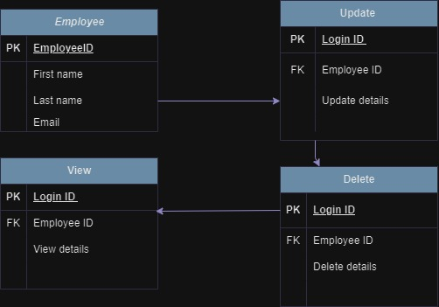

**Team Members:**

Patnam Rahul

Punith.R

Rathika . J